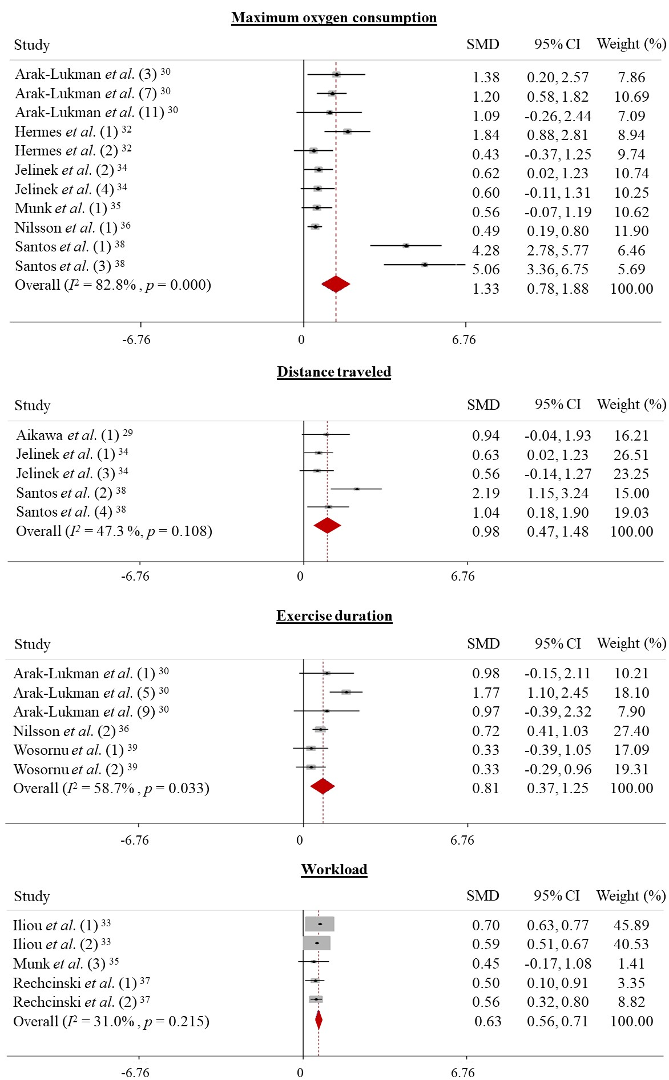
Supplementary Fig. 1. Forest plot of physical performance evaluated by different variables: maximum oxygen consumption, distance travelled, exercise duration and workload in patients undergoing myocardial revascularization (CABG and PCI). SMD, standardized mean difference.

Supplementary Table 1. Risk of bias assessment for each study included in the systematic review and meta-analysis.
Study | Absence of allocation secrecy | Absence of masking (blinding) | Incomplete follow-up | Selective reporting of outcomes | Other limitations | Quality
Aikawa et al. [1] | Not | Not | Not | Not | Not | High
Arak-Lukman et al. [2] | Not | Not | Not | Not | Not | High
Aron et al. [3] | Not | Not | Not | Not | Not | High
Hermes et al. [4] | Not | Not | Not | Not | Not | High
Iliou et al. [5] | Yes | Not | Not | Not | Not | Moderate
Jelinek et al. [6] | Not | Not | Not | Not | Not | High
Munk et al. [7] | Not | Not | Not | Not | Not | High
Nilsson et al. [8] | Not | Not | Not | Not | Not | High
Rechciński et al. [9] | Not | Not | Not | Not | Not | High
Santos et al. [10] | Not | Not | Not | Not | Not | High
Szmigielska et al. [11] | Not | Not | Not | Not | Not | High
Chuang et al. [12] | Not | Not | Not | Not | Not | High
Wosornu et al. [13] | Not | Not | Not | Not | Not | High

Reference:

[1] Aikawa P, Signori LU, Hauck M, Pereira APC, Paulitsch RG, da Silva CTM, et al. Effects of physical training on endothelium after coronary artery bypass graft. Revista Brasileira De Medicina Do Esporte. 2015; 21: 467–471.
[2] Arak-Lukmann A, Zilmer M, Maaroos J, Zilmer K, Vihalemm T, Kullisaar T, et al. Oxidative stress before and after exercise conditioning in patients following surgical revascularization of the myocardium. International Journal of Rehabilitation Research. 2002; 25: 305–312.
[3] Aron A, Klinger TA, McConnell TR. Cardiac rehabilitation outcomes no different after on-pump versus off-pump coronary artery bypass surgery. Journal of Cardiopulmonary Rehabilitation and Prevention. 2007; 27: 35–41.
[4] Hermes BM, Cardoso DM, Gomes TJN, Santos TDD, Vicente MS, Pereira SN, et al. Short-term inspiratory muscle training potentiates the benefits of aerobic and resistance training in patients undergoing CABG in phase II cardiac rehabilitation program. Revista Brasileira De Cirurgia Cardiovascular. 2015; 30: 474–481.
[5] Iliou M, Pavy B, Martinez J, Corone S, Meurin P, Tuppin P. Exercise training is safe after coronary stenting: a prospective multicentre study. European Journal of Preventive Cardiology. 2015; 22: 27–34.
[6] Jelinek HF, Huang ZQQ, Khandoker AH, Chang D, Kiat H. Cardiac rehabiltation outcomes following a 6-week program of PCI and CABG Patients. Frontiers in Physiology. 2013; 4: 302.
[7] Munk PS, Staal EM, Butt N, Isaksen K, Larsen AI. High-intensity interval training may reduce in-stent restenosis following percutaneous coronary intervention with stent implantation. American Heart Journal. 2009; 158: 734–741.
[8] Nilsson BB, Lunde P, Grøgaard HK, Holm I. Long-Term Results of High-Intensity Exercise-Based Cardiac Rehabilitation in Revascularized Patients for Symptomatic Coronary Artery Disease. The American Journal of Cardiology. 2018; 121: 21–26.
[9] Rechciński T, Kałowski M, Kasprzak JD, Trzos E, Kurpesa M. Beneficial effects of cardiac rehabilitation in patients with incomplete revascularization after primary coronary angioplasty. European Journal of Physical and Rehabilitation Medicine. 2013; 49: 785–791.
[10] Dos Santos T, Pereira S, Portela LO, Cardoso D, Dal Lago P, Dos Santos Guarda N, et al. Moderate-to-high intensity inspiratory muscle training improves the effects of combined training on exercise capacity in patients after coronary artery bypass graft surgery: a randomized clinical trial. International Journal of Cardiology. 2019; 279: 40–46.
[11] Szmigielska K, Szmigielska-Kapłon A, Jegier A. The Influence of Comprehensive Cardiac Rehabilitation on Heart Rate Variability Indices after CABG is more Effective than after PCI. Journal of Cardiovascular Translational Research. 2018; 11: 50–57.
[12] Chuang T, Sung W, Chang H, Wang R. Effect of a virtual reality-enhanced exercise protocol after coronary artery bypass grafting. Physical Therapy. 2006; 86: 1369–1377.
[13] Wosornu D, Allardyce W, Ballantyne D, Tansey P. Influence of power and aerobic exercise training on haemostatic factors after coronary artery surgery. British Heart Journal. 1992; 68: 181–186.

